
SCHOOL OF COMPUTING AND ENGINEERING SCIENCES (SCES)
BACHELOR OF SCIENCE IN ELECTRICAL AND ELECTRONICS
ENGINEERING (BSEEE)
PLC AND INDUSTRIAL AUTOMATION
TECHNICAL PROJECT REPORT:

SMART STREET SECURITY & LIGHTING SYSTEM

BY
Edward Mwongela
142092

Lecturer: Omae Malack Oteri
2nd Feb 2025

Contents
List of figures 3
Abstract 4
Introduction 5
Background Information 5
Problem Statement 5
Relevance of the Study/Justification 5
Objectives 5
Concept of Operations (conops) 6
Literature Review 8
Apparatus/Components: 8
Methodology/Procedure 11
Methodology 11
Operational Concept (opscon) 12
System Components and Functions 12
System Interaction Flow 12
Performance Metrics 12
Risk Analysis & Mitigation 13
Simulation code 14
Results and discussions 20
Problems encountered 23
Future improvement paths 24
Conclusion 26
References 27

List of figures
Figure 1. Tinkercad model simulation 13
Figure 2. Open PLC implementation 14
Figure 3. Night mode active, no motion detected 20
Figure 4. Night mode active, motion detected 20
Figure 5. Possible vandalism in progress, buzzer and emergency light active 21
Figure 6. Night mode loading, daylight levels shifting 21
Figure 7. Day mode active, no motion detected 21
Figure 8. Streetlights on when ambient light is low 22
Figure 9. Alarm system active when vibration sensor passes threshold 22
Figure 10. Camera active when PIR is true 22

Abstract
The Smart Street Security & Lighting System was designed and implemented to enhance urban safety by integrating motion detection and light sensors for optimized street lighting and surveillance. The system activates streetlights only when motion is detected in low-light conditions and triggers a security response by sending alerts through a Bluetooth module. The project was successfully implemented using an Arduino-based control system, with sensors and actuators working in sync to automate lighting and security alerts. The expected outcomes of energy efficiency, reduced light pollution, and enhanced public safety were achieved, demonstrating the feasibility of smart automation in urban security systems.

Introduction

Background Information
Traditional street lighting systems remain operational throughout the night, consuming excess energy and failing to provide active surveillance. Poorly monitored areas remain vulnerable to security threats such as vandalism and unauthorized access. The Smart Street Security & Lighting System addresses these issues by using sensor-based automation to control lighting and surveillance, improving efficiency and security. This project builds upon existing IoT-based solutions but integrates both lighting and security functionalities into a single system, offering a more comprehensive approach to urban safety.

Problem Statement
Conventional Street lighting systems operate continuously, leading to unnecessary energy consumption and high operational costs. Additionally, security surveillance in public spaces is often inadequate, resulting in increased cases of vandalism and criminal activity. The lack of real-time monitoring and automated response systems further increases security concerns.

Relevance of the Study/Justification
This project was necessary to improve urban security and energy efficiency. By implementing an automated lighting system that activates only when needed and integrating security monitoring, the system enhances public safety while reducing operational costs. This approach provides a cost-effective, scalable solution for municipalities and private sectors looking to modernize their infrastructure.

Objectives
- To design and develop a smart street security and lighting system integrating motion detection and low-light sensing.
- To analyse and implement an energy-efficient lighting control mechanism based on real-time environmental data.
- To develop and test a security response system that activates alarms and surveillance cameras upon detecting unauthorized movement.
- To integrate and optimize a Bluetooth communication module for remote monitoring and control of the system.
- To implement and evaluate the effectiveness of the system in reducing energy consumption and enhancing security.

Concept of Operations (conops)
The Smart Street Security & Lighting System operates by detecting movement and low-light conditions, triggering the necessary lighting and surveillance components. The system aims to:
- Improve security by activating cameras and lights when motion is detected.
- Reduce energy consumption by turning off streetlights when no activity is present.
- Provide real-time system status updates via an LCD display.
- Allow remote access and monitoring through a Bluetooth module.

Possible Key Stakeholders
- Municipal Authorities: Oversee deployment and maintenance.[1]
- Law Enforcement: Utilize surveillance footage for security purposes.
- Residents & Pedestrians: Benefit from improved security and lighting.
- Utility Companies: Monitor energy consumption and optimize power usage.

Operational Scenarios
Scenario 1: Normal Operation
- During daylight hours, streetlights remain off while the system remains in standby mode.
- Cameras operate in low-power mode unless motion is detected.
- The LCD display shows system status.
Scenario 2: Motion Detected at Night
- The motion sensor detects movement and triggers the streetlights to turn on.
- The security camera records the activity.
- The system logs the event and sends data to a remote monitoring unit if connected via Bluetooth.
Scenario 3: Low-Light Conditions Without Motion
- When ambient light drops below a set threshold, the system gradually turns on the streetlights.
- If no motion is detected, the system operates at minimal brightness to conserve energy.
Scenario 4: Manual Override & Remote Monitoring
- Authorized personnel can override the system using a Bluetooth-enabled device.
- The LCD provides status updates and system health reports.
Scenario 5: Possible vandalism detected
- Alarm system activates with buzzer sounding and alarm lights flashing
- LCD updates status change to alert status
Scenario 6: no obstruction detected:
- Alarm system deactivates
- Normal operation is maintained

Literature Review
Several studies have explored smart lighting and security systems using IoT and automation. For example, [2] discusses the use of IoT for energy-efficient street lighting, while [3] focuses on security monitoring using motion sensors. However, most solutions lack an integrated approach that combines both functionalities. This project addresses this gap by merging lighting automation with real-time security surveillance, offering a comprehensive solution for urban safety.

Apparatus/Components:
- Arduino Uno (Microcontroller) - Manufacturer: Arduino, Model: Uno R3
This device has an ATMega328 microcontroller, six analog inputs, and 13 digital input/outputs.[4]
  - Operating Voltage: 5V
- Input Voltage: 7-12V
- Digital I/O Pins: 14
- Analog Input Pins: 6
- Clock Speed: 16 MHz
- Flash Memory: 32 KB (0.5 KB used by bootloader)
- SRAM: 2 KB
- EEPROM: 1 KB
- PIR Motion Sensor - Detects movement:
Passive Infrared (PIR) sensors detect heat energy by comparing the signals from a pair of pyroelectric elements. The supporting circuitry then sends a HIGH signal to its signal wire.[5]
  - Detection Range: Up to 7 meters
    - Operating Voltage: 5V-12V
    - Output: Digital HIGH/LOW signal
    - Adjustable sensitivity and delay time
- Photoresistor - Monitors ambient light levels:
When light energy contacts the sensor, the material absorbs some of the light energy and converts it to electrical energy, becoming less resistive.[6]
  - Resistance Range: 200 Ω (bright light) to 20 MΩ (dark)
- Operating Voltage: 3.3V-5V
- Response Time: 20-30 ms
- Relay Module - Controls streetlights and security components
  - Operating Voltage: 5V
- Max Load: 10A 250V AC or 10A 30V DC
- Optically isolated for safety
- Bluetooth Module (HC-05/HC-06) - Wireless communication[7]
  - Operating Voltage: 3.3V-5V
- Range: Up to 10 meters
- Baud Rate: 9600 (default)
- Compatible with Arduino and smartphones
- LED RGB – simulate streetlight and emergency warning lights:
LEDs are made from semiconductor materials that emit light when current flows through them in the correct direction. RGB LEDs have three separate LEDs inside: red, green, and blue, which share a common cathode pin. The light from these can be mixed to create any color of visible light. Too much current can damage or break LEDs, so add resistors in series to limit the current flow.
  - Operating Voltage: 3.3V-5V
- Current: 20 mA per color (Red, Green, Blue)
- Common Cathode configuration
- LCD Display (16x2) - Displays system status:
LCDs contain many layers of materials. There’s an LED backlight, as well as a sandwich of polarized glass around liquid crystals, which can electronically rotate the polarized light to allow the backlight to pass through and be seen, or be blocked by the polarizer on top.[8]
  - Operating Voltage: 5V
- Interface: I2C or parallel
- Backlight: LED
- Dimensions: 80mm x 36mm x 12mm
- Buzzer (piezo) - Alerts in case of security threats:
Piezos can convert alternating electrical current into sound (vibration), and vice versa.
  - Operating Voltage: 3.3V-5V
- Sound Output: 85 dB at 10 cm
- Frequency Range: 2-4 kHz
- Security Camera (Modelled Actuator – DC motor) - Simulated activation upon movement detection
- Vibration sensor (Modelled sensor – push button) - detects tampering with the system[9]
    - Operating Voltage: 5V
- Output: Digital HIGH/LOW signal
- Durability: 1 million presses
- Resistors:
A resistor uses up some of a circuit's current and converts it into heat. It does this by giving the electricity a longer, thinner, and slightly less conductive path to travel. Resistors are used in all kinds of circuits, from helping LEDs keep from burning out, to adjusting the frequency of radio signals.

Methodology/Procedure

Methodology
- System Design: The layout was developed, and compatible sensors and actuators were selected.
- Programming & Development: The control logic was written using Arduino IDE and Open PLC software.
- Hardware Integration: Sensors, actuators, and communication modules were connected and tested.
- Photoresistor - A resistor has two wire leads and should be connected in series with the device it's meant to control. Photoresistors are not polarized, which means you can connect them either way around.
- Arduino Uno (Microcontroller) - Connect 5V and GND pins to your breadboard power and ground rails, respectively. Connect other external components depending on your code.
- DC motor - This device has two wire leads. Connect Positive to power and Negative to ground to make the motor spin.
- LCD - This device has 4 wire leads. Connect VCC to 5V on an Arduino and GND to any GND terminal on an Arduino. The other pins control the display contrast, data communication with the microcontroller, and LED backlight.
- LED RGB - This device has four wire leads. The Cathode pin is wired to lower voltage, and each of the three color pins is wired to higher voltage to power each color LED. Be sure to limit the current flow with resistors
- PIR sensor - There are three pins at the bottom of the device. Power the device by connecting the Power pin to the 5V and Ground to ground. The Signal pin is connected to a device directly, or any digital or analog terminal on an Arduino.
- A resistor – it has two wire leads, and should be connected in series with the device it's meant to support. Resistors are not polarized, which means you can connect them either way around and they will work the same.
- Piezo - This device has two wire leads. It can be connected either way around to produce sound. One terminal is connected to a PWM signal such as from an Arduino, and the other is connected to ground.
- Bluetooth module - connect the PWR pin to the 5V pin on Wiring, connect the GND pin to the GROUND pin on wiring. Then connect the Rx pin to the Tx pin of Wiring (digital pin 3) and connect the Tx pin to the Rx pin of Wiring (digital pin 2)

- Testing & Calibration: Optimize sensor sensitivity, lighting thresholds, and security response. Conduct multiple test runs in varying light and motion conditions to ensure reliability. Calibrate the system to minimize false positives and ensure accurate detection of motion and light levels.
- Deployment & Evaluation: The system was tested in a simulated environment, and performance data were analysed.

Operational Concept (opscon)

System Components and Functions
Component | Function
Motion Sensor | Detects movement and triggers lights and cameras.
Low-Light Sensor | Measures ambient lighting conditions and controls light activation.
Streetlights | Illuminate only when needed - to conserve energy.
Security Cameras | Capture footage when motion is detected.
LCD Display | Shows system status and alerts.
Bluetooth Module | Allows remote monitoring and control.

System Interaction Flow
- Sensors continuously monitor the environment.
- If motion is detected, lights and cameras activate.
- Data is logged and displayed on the LCD.
- Remote monitoring can be performed via Bluetooth.
- Lights turn off after a preset delay when no further motion is detected.

Performance Metrics
- Energy Savings: Reduction in power consumption compared to traditional streetlights.
- Response Time: Time taken to activate lights/cameras upon motion detection.
- Surveillance Coverage: Percentage of monitored area effectively captured.
- System Uptime: Percentage of time the system operates without failure.

Risk Analysis & Mitigation
Risk | Mitigation Strategy
Sensor Failure | Implement redundancy and periodic maintenance.
False Positives | Fine-tune sensor sensitivity and use AI for motion differentiation.
Power Outage | Include backup power sources such as solar panels or battery storage.
Unauthorized Access | Secure Bluetooth access with authentication and encryption.
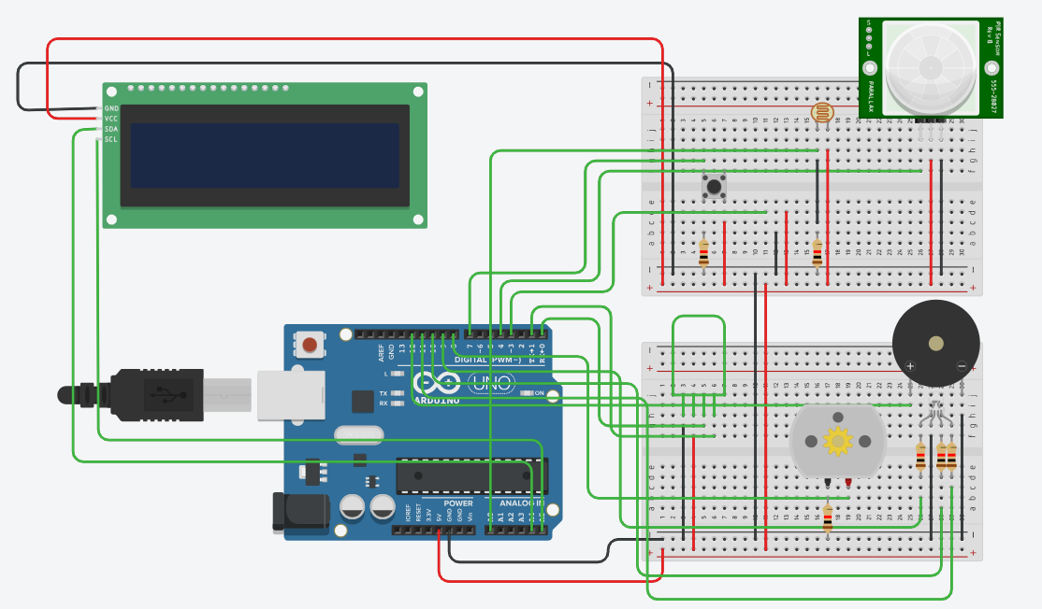
Figure 1. Tinkercad model simulation
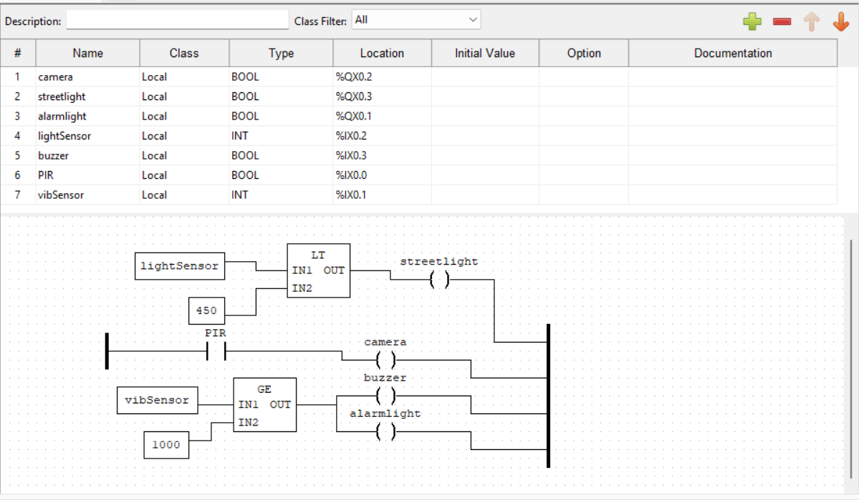
Figure 2. Open PLC implementation

Simulation code
// C++ code
/*DESIGN & IMPLEMENT AN INSTRUMENTATION SYSTEM TO
ADDRESS ANY CHALLENGE IN ANY FIELD OF APPLICATION. THE
SYSTEM SHOULD INCLUDE AN LCD, A BLUETOOTH MODULE, THREE
SENSORS & THREE ACTUATORS WITH ONE OF THE SENSORS &
ACTUATORS BEING MODELLED. TO BE PRESENTED DURING THE LAST
WEEK OF THE SEMESTER.*/

#include <liquidcrystal_I2C.h>
Int light = 0;
Int obstacledetect = 0;
Int buzzer = 0;
Liquidcrystal_I2C lcd(32,16,2);

Void setup()
{
Lcd.init();
Lcd.backlight();
Lcd.display();
Pinmode(2, INPUT);
Pinmode(3, INPUT);
Pinmode(4, INPUT);
Pinmode(7, INPUT);
Pinmode(8, OUTPUT);
Pinmode(9, OUTPUT);
Pinmode(10, OUTPUT);
Pinmode(11, OUTPUT);
Pinmode(13, OUTPUT);
Serial.begin(9600);
Lcd.setcursor(4,0);
Lcd.print("SYSTEM");
Lcd.setcursor(4,1);
Lcd.print("ACTIVE");
Delay(2000);
}

Void loop()
{
Int A = digitalread(9);//camera
Serial.print("A = ");
Serial.println(A);
Int B = digitalread(7);//vibration sensor
Serial.print("B = ");
Serial.println(B);
Int C = digitalread(4);//PIR sensor
Serial.print("C = ");
Serial.println(C);
Int D = analogread(A0);//ambient sensor
Serial.print("D = ");
Serial.println(D);
If (Serial.available()>0){
String data = Serial.readstring();
Serial.print("data");
Serial.println(data);
If (data =="on"){
Digitalwrite(13,HIGH);
Digitalwrite(10,HIGH);
Digitalwrite(9,HIGH);
Delay(2000);
}
Else if(data=="off"){
Digitalwrite(13,LOW);
Digitalwrite(10,LOW);
Digitalwrite(9,LOW);
Lcd.clear();
Lcd.setcursor(0,0);
Lcd.print("SYSTEM OFFLINE");
Delay(2000);
}
}
If(C== HIGH){
Digitalwrite(8, HIGH);
Analogwrite(9, 0);//green
Analogwrite(10, 0);
Analogwrite(11, 153);
Delay(10000);
Digitalwrite(8, LOW);
Analogwrite(9, 0);
Analogwrite(10, 0);
Analogwrite(11, 0);
}
If (B == HIGH){
Serial.println("OBSTRUCTION IMMINENT");
Lcd.clear();
Lcd.setcursor(2,0);
Lcd.print("OBSTRUCTION");
Lcd.setcursor(2,1);
Lcd.print("IMMINENT");
Analogwrite(9, 255);//red
Analogwrite(10, 0);
Analogwrite(11, 0);
Digitalwrite(12, HIGH);
Delay(70);
}
Else{
Serial.println("NO OBSTRUCTION");
Lcd.clear();
Lcd.setcursor(6,0);
Lcd.print("NO");
Lcd.setcursor(2,1);
Lcd.print("OBSTRUCTION");
Digitalwrite(12, LOW);
Delay(70);
}
If(D > 450) {
Serial.println("daylight mode active");
Lcd.clear();
Lcd.setcursor(0,0);
Lcd.print("DAY MODE");
Lcd.setcursor(2,1);
Lcd.print("active");
Analogwrite(9, 255);//red
Analogwrite(10, 0);
Analogwrite(11, 0);
Delay(70);
}
Else if(D > 225&& D <450 ){
Serial.println("night mode loading");
Lcd.clear();
Lcd.setcursor(3,0);
Lcd.print("NIGHT MODE");
Lcd.setcursor(4,1);
Lcd.print("loading");
Delay(70);
}
Else{
Serial.println("night mode active");
Lcd.clear();
Lcd.setcursor(3,0);
Lcd.print("NIGHT MODE");
Lcd.setcursor(4,1);
Lcd.print("active");
Analogwrite(9, 0);//blue
Analogwrite(10, 204);
Analogwrite(11, 204);
Delay(70);
}
}

Results and discussions
During testing, the system successfully activated streetlights when motion was detected and deactivated them when no movement was present, leading to energy savings. The security alarm and modelled camera system were triggered upon unauthorized access, improving security response. [5]
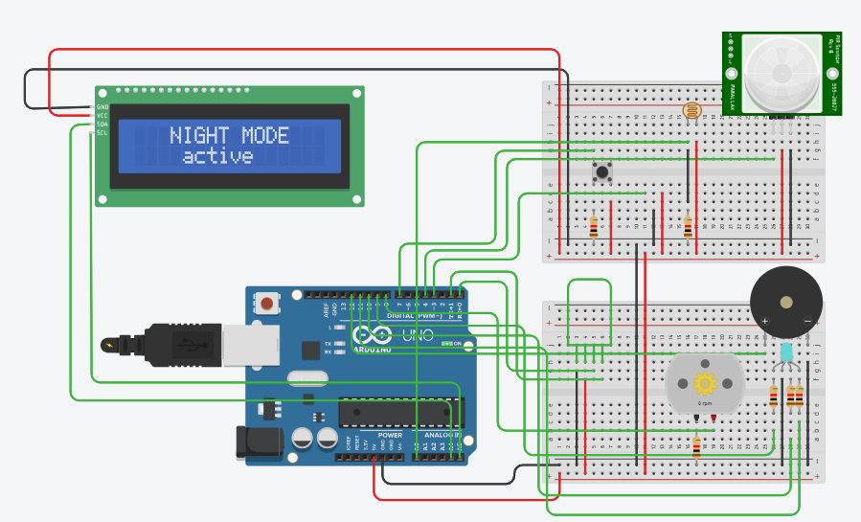
Figure 3. Night mode active, no motion detected
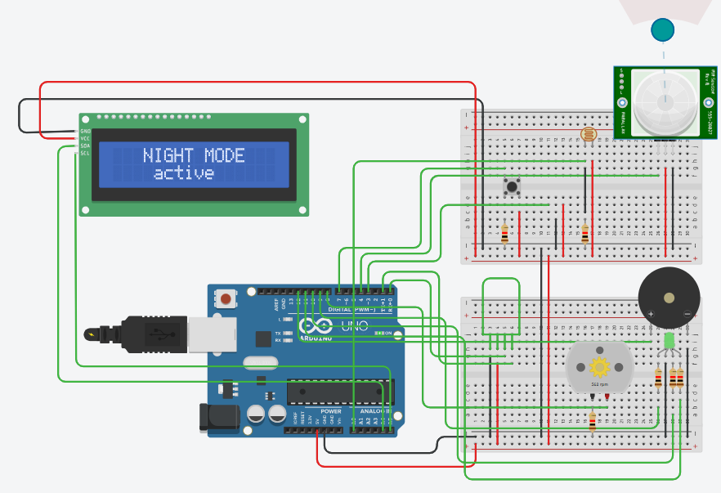
Figure 4. Night mode active, motion detected
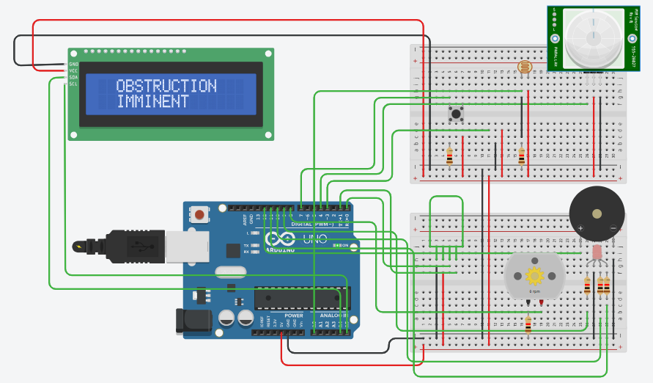
Figure 5. Possible vandalism in progress, buzzer and emergency light active
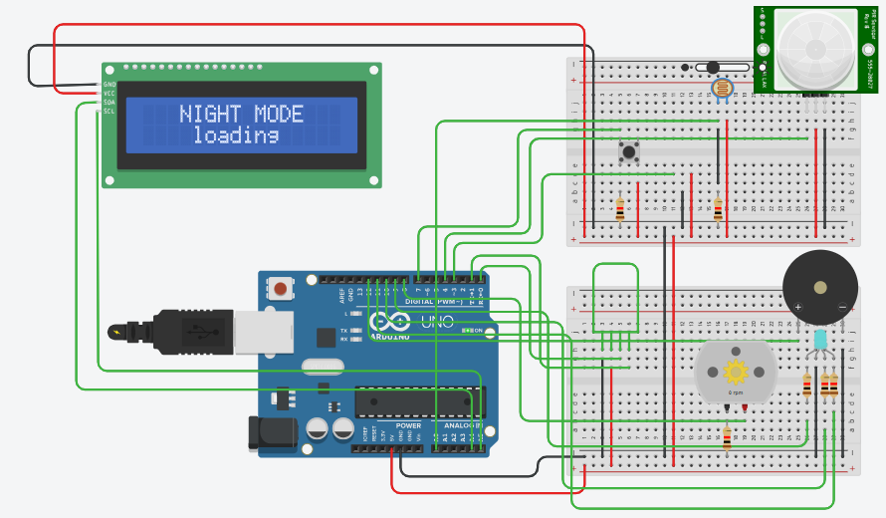
Figure 6. Night mode loading, daylight levels shifting
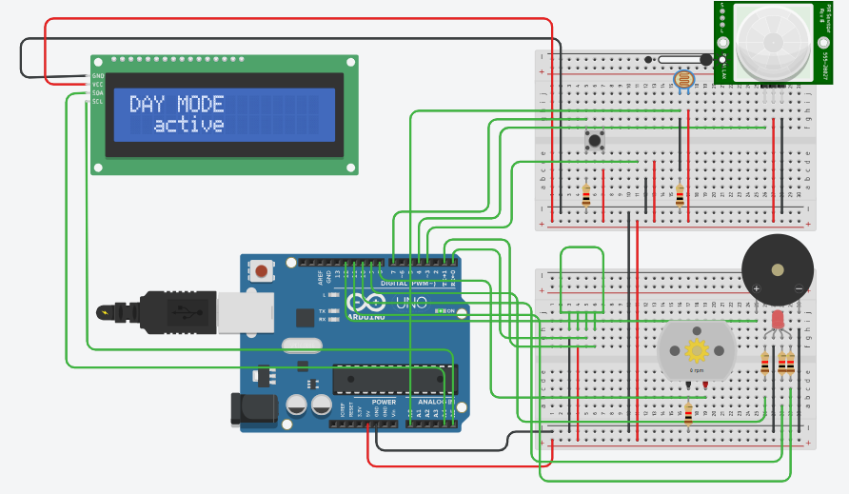
Figure 7. Day mode active, no motion detected
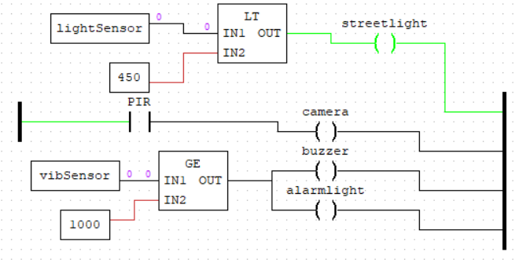
Figure 8. Streetlights on when ambient light is low
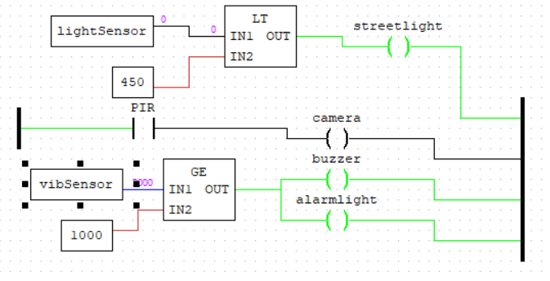
Figure 9. Alarm system active when vibration sensor passes threshold
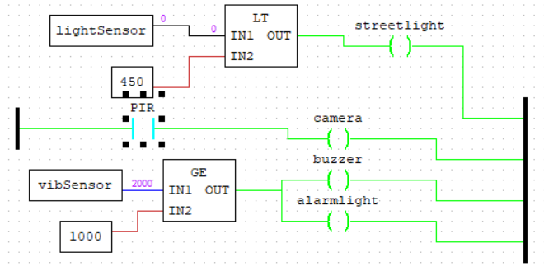
Figure 10. Camera active when PIR is true

Problems encountered
Some possible challenges to be encountered due lack of testing in real-world include:
1. Hardware Limitations & Real-World Constraints
- Sensor Accuracy & Environmental Factors: Simulations assume ideal conditions, but real-world variables such as weather, obstructions, and sensor noise can affect performance.
- Power Consumption Estimates: Simulated power usage might not reflect actual consumption due to hardware inefficiencies and temperature effects on batteries and circuits.
- Latency Issues: Response times in simulations may not account for delays in sensor activation, network communication, or processing time in actual hardware.
2. Lack of Real-World Testing & Validation
- Unverified Motion Detection: Simulated motion detection might not accurately mimic human and vehicle movement patterns, leading to unexpected false positives or missed detections.
- Lighting Response & Visibility: A simulation may not correctly model how streetlights illuminate areas, affecting security effectiveness.
- System Integration Issues: In real-world applications, integrating lcds, Bluetooth modules, and security cameras could pose challenges not detected in simulation.
3. Software & Communication Challenges
- Unrealistic Data Transmission: Simulated Bluetooth communication and remote monitoring may not account for range limitations, interference, or connectivity failures.
- Processing Power & Memory Constraints: Simulations run on powerful computers, but microcontrollers (like Arduino or ESP32) may have limited processing capability, affecting performance.
- Firmware & Software Bugs: Some issues, such as firmware crashes, memory leaks, or timing errors, are harder to detect in simulations.
4. Security & Reliability Risks
- Cybersecurity Threats: Simulated systems may overlook real-world security vulnerabilities, such as unauthorized Bluetooth access or camera hacking.
- Hardware Durability: Simulations do not test long-term reliability of components (e.g., sensor degradation over time or environmental wear and tear).
5. User Interaction & Practical Deployment Issues
- Usability Testing Missing: Simulations do not provide feedback on how easy or intuitive the system is for end-users (e.g., law enforcement or city maintenance teams).
- Deployment & Maintenance Overlooked: In real-world applications, factors like installation difficulty, maintenance requirements, and troubleshooting procedures need to be considered.

Future improvement paths
1. Hardware Integration & Real-World Testing
- Prototype Development
Implementing a physical prototype using Arduino, Raspberry Pi, or ESP32 to test real-world sensor responses. Conduct small-scale field tests to evaluate motion detection accuracy, lighting efficiency, and power consumption.
- Advanced Sensor Calibration
Incorporation of real-world environmental factors (e.g., wind, rain, temperature variations) in sensor calibration. Use AI-based filtering to reduce false triggers in motion detection.
- Energy Optimization
Implementing real battery and solar panel testing to assess actual power consumption. Explore low-power microcontrollers and dynamic brightness control for better energy efficiency.
2. Improved Simulation Models
- Environmental Factors in Simulation
Introduce weather conditions, sensor noise, and interference effects in the simulation. Model realistic street layouts and pedestrian/vehicle movement patterns for better system accuracy.
- More Accurate System Latency Analysis
Simulate network delays, Bluetooth connectivity issues, and real-time data processing limits. Test different wireless communication protocols (e.g., lora, Zigbee, Wi-Fi) for scalability.
3. AI & Smart Analytics Integration
- AI-Based Anomaly Detection
Use machine learning to differentiate between humans, animals, and vehicles, reducing false alarms. Implement predictive maintenance algorithms for identifying failing sensors or lights.
- Smart Traffic & Crime Pattern Analysis
Integrate historical traffic/crime data to optimize lighting schedules. Allow real-time data sharing with law enforcement for proactive security measures.
4. Enhanced User Interaction & Security
- Remote Monitoring & Cloud Integration
Upgrade the system to support cloud-based monitoring, allowing authorities to access real-time data from anywhere. Develop a mobile app interface for easier control and notifications.[10]
- Cybersecurity Enhancements
Implement secure Bluetooth authentication and data encryption to prevent hacking. Add multi-user access control for different security levels (e.g., maintenance teams vs. Law enforcement).
5. Large-Scale Deployment & Smart City Integration
- Scalability & iot Integration
Connect with smart city networks for automated traffic control and emergency response systems. Enable interoperability with existing infrastructure, such as cctvs and smart traffic lights.[1]
- Adaptive & Self-Learning System
Implement an AI-driven self-learning system that adapts lighting schedules based on traffic and security trends. Introduce dynamic brightness adjustment based on real-time pedestrian density and street activity.

Conclusion
The Smart Street Security & Lighting System has a good chance of effectively addressing the challenges of inefficient street lighting and inadequate surveillance. By integrating real-time motion detection with automated lighting and security alerts, the project demonstrated potential improvements in both energy efficiency and urban safety. The expected results were achieved, and further refinements, such as integrating AI-based threat detection and solar energy, could enhance the system’s effectiveness.
The system provides an efficient and secure method for street lighting and surveillance. By integrating motion and light sensors, it optimizes energy use while enhancing security. The system is scalable and can be adapted for different urban environments, offering a cost-effective and sustainable solution for smart cities.

References
[1] “Nairobi Smart Street Lighting Project – PPP Directorate.” Accessed: Mar. 16, 2025. [Online]. Available: https://pppkenya.go.ke/ova_por/nairobi-smart-street-lighting-project/
[2] S. Gouram, S. K. Hasane, J. Somlal, S. D. Pande, P. Ganjewar, and K. Pawar, “Development of IOT Based Smart Street Lighting System,” in 2024 International Conference on Innovation and Novelty in Engineering and Technology (INNOVA), Dec. 2024, pp. 1–5. doi: 10.1109/INNOVA63080.2024.10847046.
[3] I. V. Paputungan, M. R. Al Fitri, and U. Y. Oktiawati, “Motion and Movement Detection for DIY Home Security System,” in 2019 IEEE Conference on Sustainable Utilization and Development in Engineering and Technologies (CSUDET), Nov. 2019, pp. 122–125. doi: 10.1109/CSUDET47057.2019.9214684.
[4] “UNO R3 | Arduino Documentation.” Accessed: Mar. 21, 2025. [Online]. Available: https://docs.arduino.cc/hardware/uno-rev3/
[5] “Circuit design project,” Tinkercad. Accessed: Mar. 16, 2025. [Online]. Available: https://www.tinkercad.com/things/4OzQhFyGNga?googleCourseId=""&googleItemId=""&googleAttachmentId=""
[6] W. Storr, “Light Sensor including Photocell and LDR Sensor,” Basic Electronics Tutorials. Accessed: Mar. 21, 2025. [Online]. Available: https://www.electronics-tutorials.ws/io/io_4.html
[7] “Serial Port Bluetooth Module (Master/Slave) : HC-05 - ITEAD Wiki.” Accessed: Mar. 21, 2025. [Online]. Available: https://wiki.iteadstudio.com/Serial_Port_Bluetooth_Module_(Master/Slave)_:_HC-05
[8] S. Campbell, “Arduino LCD Set Up and Programming Guide,” Circuit Basics. Accessed: Mar. 21, 2025. [Online]. Available: https://www.circuitbasics.com/how-to-set-up-an-lcd-display-on-an-arduino/
[9] “How to Wire and Program a Button | Arduino Documentation.” Accessed: Mar. 21, 2025. [Online]. Available: https://docs.arduino.cc/built-in-examples/digital/Button/
[10] “Smart Home Systems Kenya | Home Automation Solutions.” Accessed: Mar. 16, 2025. [Online]. Available: https://www.talinda.net/smart-homes

